### Case#3 Predictions About Home Values

Q1. Q1. Firstly, we need to examine our data by running StatExplore. From the output and attribute information,we can see that there are 12 continuous factors and 1 binary factor (CHAS) that can be used as predictors. The target variable, MEDV, is an interval variable.

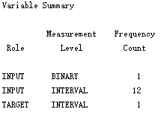

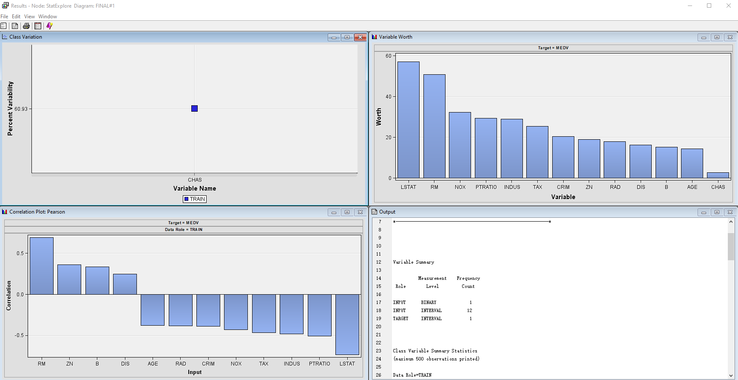

According to Variable Worth, we can see that all variables are strongly correlated with housing prices except for CHAS. Among them, the population with low education level has a very extreme negative correlation with the housing price, that is, the higher the proportion of the population with low education level is, the lower the house price is. On the contrary, the number of rooms has a very significant positive correlation with the price of the house. The more rooms there are, the higher the price of the house.

That's it for the variable analysis. Next, I will use many Model (7 different regression models, 10 different Neural Networks, Decision Tree and 3 Auto Neural) to make accurate predictions about home values and find the best model.

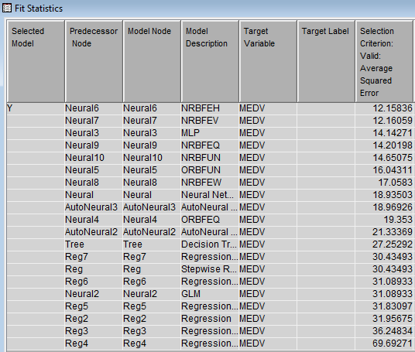

According to the result, we can see that Neural6 (Normalized Radial-Equal Height) has the lowest average squared error with 12.15836. The worst model is Partial Least Squares regression model with highest average squared error 69.69271. In this case, we choose NRBFEH as the best model to make accurate predictions about home values.

Q2.

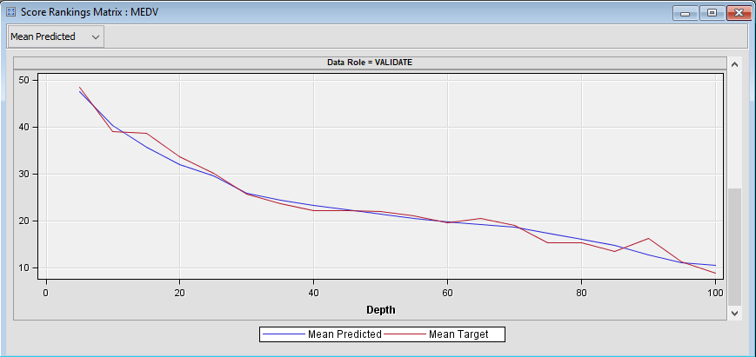

As we can see from the graph, this model is very accurate in predicting the median housing price, but generally low in predicting the high housing price, and generally high in predicting the low housing price.

In general, the more rooms you have, the higher the price of the house. The average annual NOx concentration has a huge effect on the price of the house. If NOX increases a little bit, the price of the house goes down a lot.